# Reproducing our measurements

1. To reproduce our measurements, open our Solution Eclipse Bundle by clicking the “Solution” icon on the desktop. Using the Package Explorer, you can find the following classes in the **solution.runner** package of the **ttc2016-solution** project:
   1. CrossoverConfigurationSpaceRunner
   2. InitialisationConfigurationRunner
   3. MutationConfigurationSpaceRunner

The classes contain the full configuration used for each of the three measurements.

1. To start a measurement, right-click on the respective class in the Package Explorer and choose “Run As -> Java Application”.

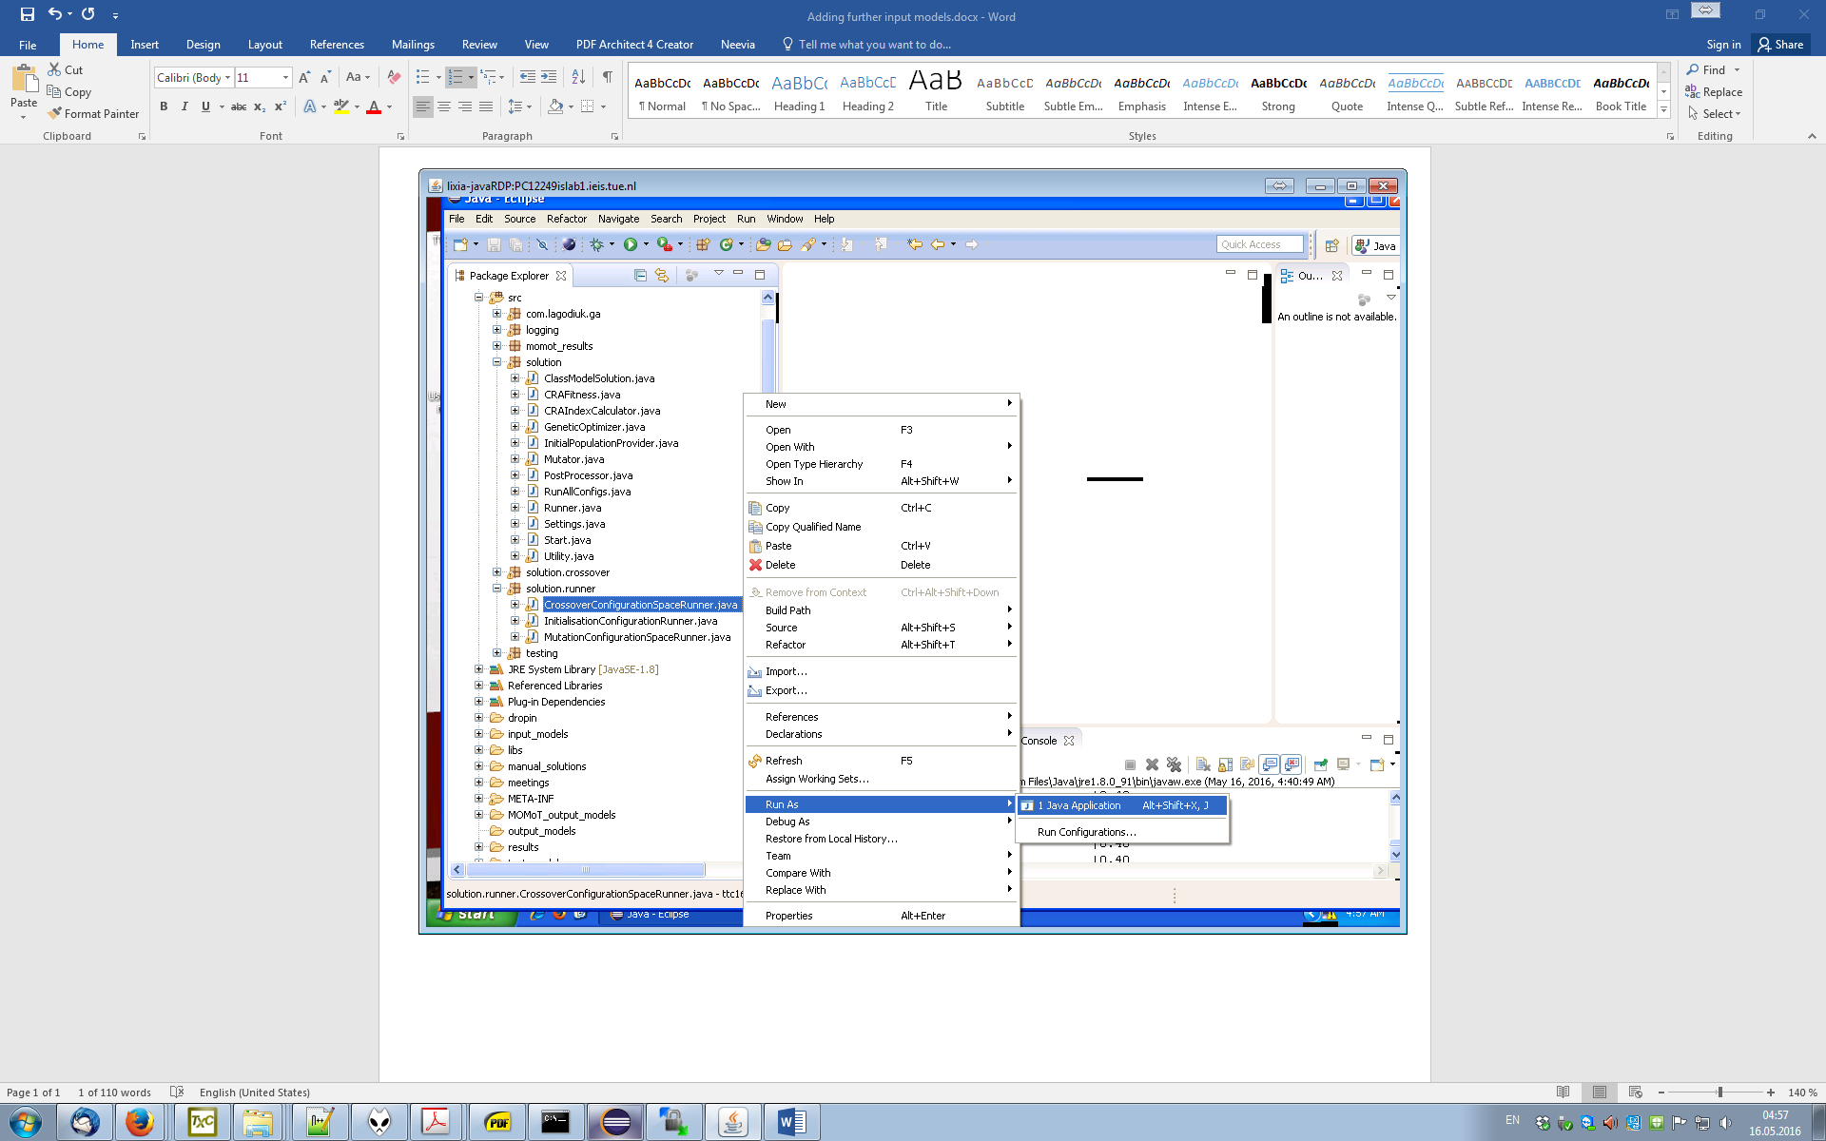

* The result log will be written to top-level folders of the **ttc-solution** project according to the input models’ name. You might have to refresh the package explorer (F5 on the root element) to see the new files.
* The best output model of each run will be written to a sub-folder of the **output_models** folder according to the input model’s name.